**Scss**

**Syntax**

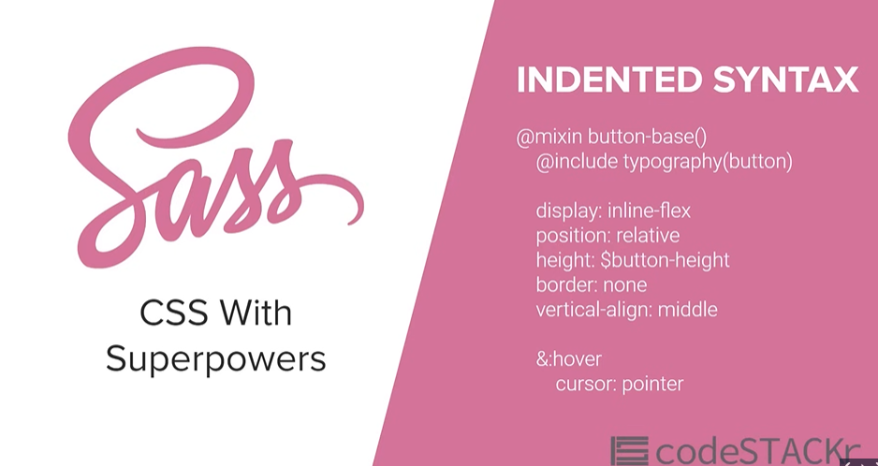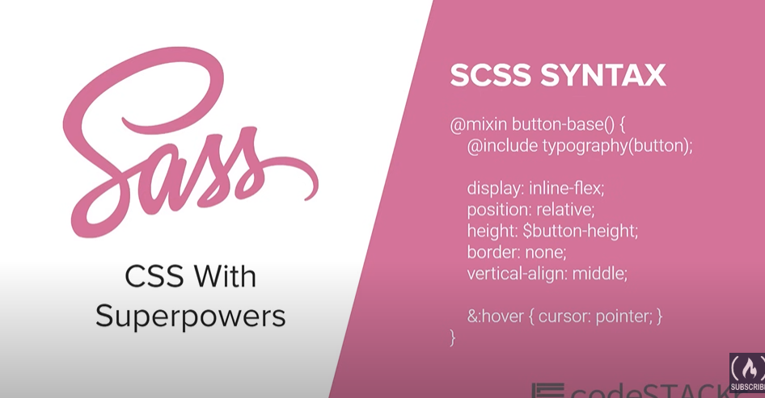**\**

* **Css with superpowers**
* **Only update in scss file**
* body {
* *background: blue;*
* }*/*# sourceMappingURL=main.css.map */*
* **Variables** 
  + **before**
  + *:root*{
  + *--primary-color*: black;
  + *--accent-color*: green;
  + *--text-color*: white;
  + }
  + body {
  + */* background: blue; */*
  + background: var(*--primary-color*);
  + }*/*# sourceMappingURL=main.css.map */*
* **After**
* *//After*
* *$primary-color*:black;
* *$accent-color*:green;
* *$text-color*:white;
* body{
* background-color: *$primary-color*;
* }
* **MAP**

**Define once**

**Use any where:**

**#scss:**

***$font-weights*:(**

**"regular" : 200 ,**

**"medium" : 500,**

**"bold" : 900**

**);**

**body{**

**background-color: *$primary-color*;**

**color: *$text-color*;**

**//example of map :**

**font-weight: map-get(*$font-weights*, bold );**

**}**

**#css**

**body {**

**background-color: black;**

**color: white;**

**font-weight: 900;**

**}**

* **Nesting**

**div-> main**

**p-> p**

**#scss**

***.main*{**

**width: 80*%*;**

**margin : 0 auto ;**

**p{**

**font-weight: map-get(*$font-weights*, bold );**

**}**

**}**

**#css**

***.main* {**

**width: 80*%*;**

**margin: 0 auto;**

**}**

***.main* p {**

**font-weight: 900;**

* **Extra note**

**div-> main**

**p-> main_para**

**& == .main**

**#scss**

**.main{**

**//If pthen**

**P{**

**}**

**//if id name**

**.main_para{**

**}**

**Or**

**#{&}_para{**

**}**

**}**

**scss**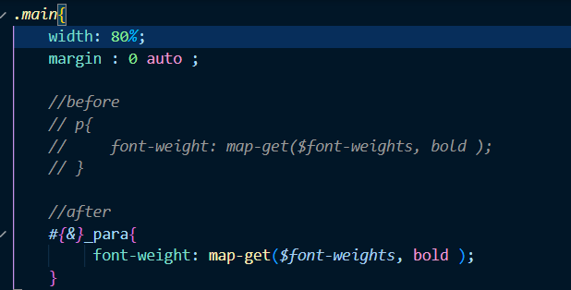

**css**

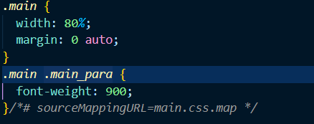

* **Partials**

**We also import 2nd scss file in 1st by @import**

**Use for long code and group app**

**Ex.**

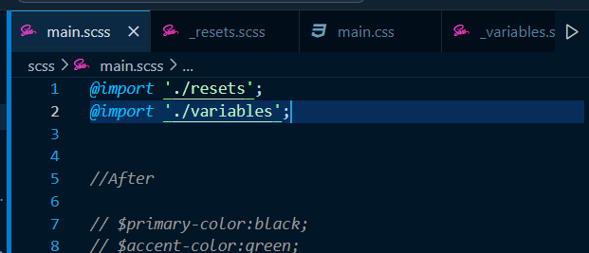

* **Functions:**

**Like simple function in which we crete a function and define the fiunction which is use in some deferent place;** 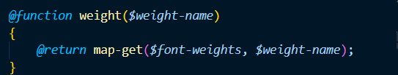

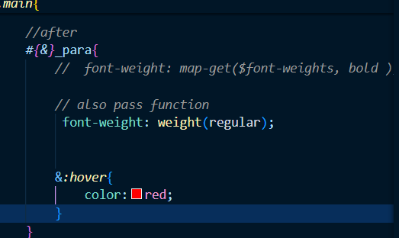

* **Mixin:**

**Group main main properties in MIXIN and use them whenever its needed;**

**1.simple mixin**

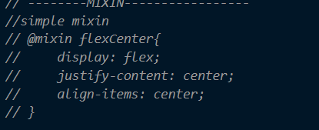

**2.parameterize**

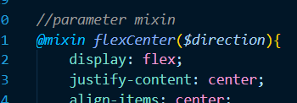

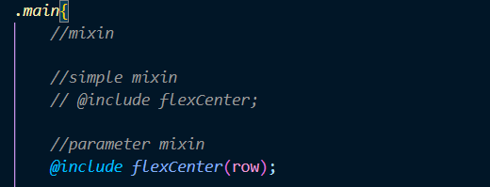

**3.color mixin:**

**Light dark theme krva use thay a bi function ype nu j che ama bi name define kri ne jya use krvu hoi ty ause kris kai che**

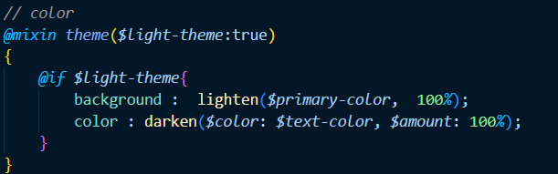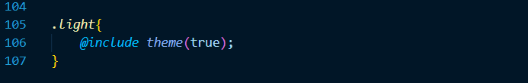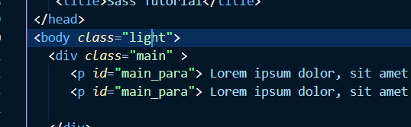

**4.mobile mixin**

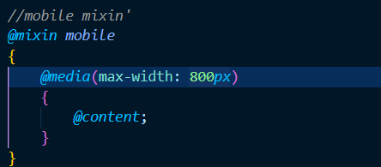

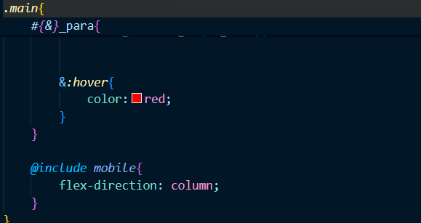

**Extends:**

**We copy any property of class to any other class by simple do extend method**

